**Adding a new Cost Item Default Cost**

The References page 'Cost Item Default Costs' lists all the Cost Items, and all the default unit costs that the superuser has assigned to those cost items.

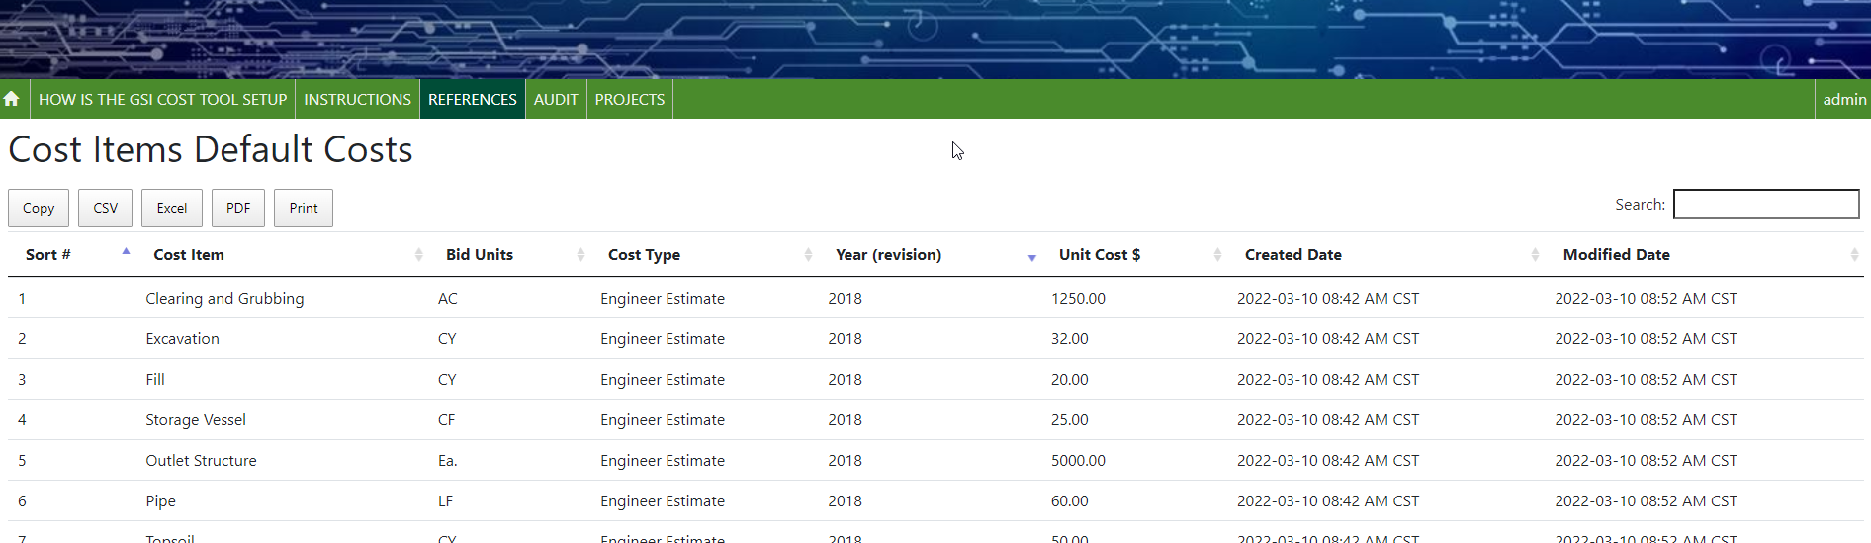

Periodically, new Cost Item 'default' costs must be added to the GSI Cost tool as the unit cost of the items change. These default costs that are presented to users in the GSI Cost Tool are stored in the 'Cost Item Default Costs'. For each cost item there can be 1 or more default costs. Each default cost is made up of 3 things.

* Cost Type – the information used to determine the unit cost – for example 'Engineer Estimate', 'Average GSI Database User value', etc.
* Year – this can be a simple year – such as 2020, 2021, 2022, etc., or a composite of the year and any unique identifier, for example year and month could be '2022-06'. The values are displayed to users sorted by the Year, so it is best to always use the year and then the unique identifier.
* Unit Cost – dollar value of the unit cost

**Note:** *Once a Cost Item Default Cost has been created, and used by users, it should not be updated. For example, the Engineer Estimate for 2018 should not be changed, even if later in 2018 the unit cost has increased. If there is a need for new values –create a new Default Cost, and add something to make it unique, for example 2018-fall, or 2018-09.*

New values are entered using the 'GSI Cost Tool Admin Page', which is only available to users who have been granted 'superuser' status. In the image below, the user has superuser status. When a superuser logs into the GSI Cost Tool, the menu in the upper right corner of the screen has 3 options. Use the first option to open the 'GSI Cost Tool Admin Page'



On the GSI Cost Tool Admin Page a superuser can add, edit, and delete data. The superuser can select any option by selecting the name of the option, or the 'Change' menu button.

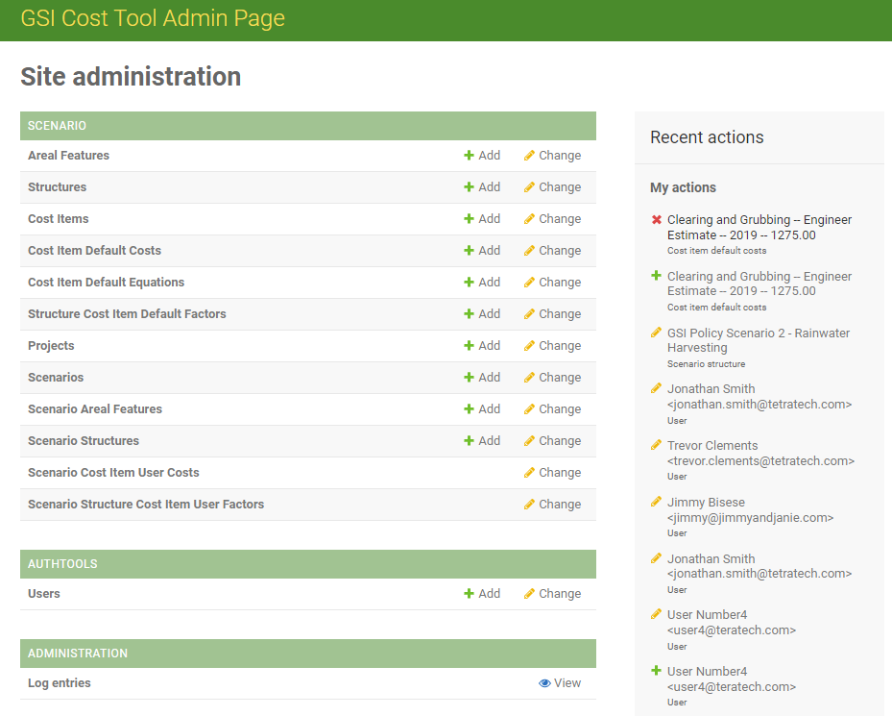

To review, and create, new default costs, select the option 'Cost Item Default Costs' from the Site administration list. The information displayed on the admin page is the same shown in the Reference page. In the image, all of the default costs are from the original values created in 2018.

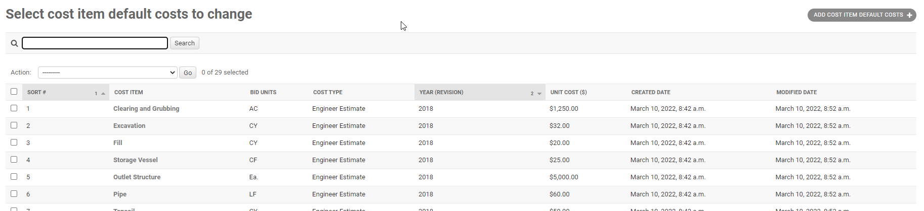

To create new value – use the button 'ADD COST ITEM DEFAULT COSTS' in the upper right corner.

In the screen that opens, select the Cost Item, and then enter the information for the new default value. Then hit the SAVE button on the lower right corner of the screen.

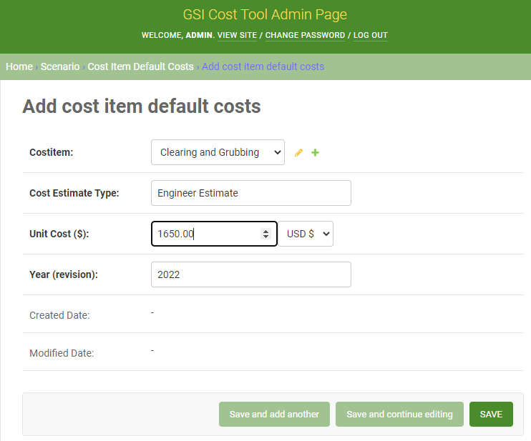

On the list of cost item default costs, the new entry should be displayed in a banner, and then added to the list.

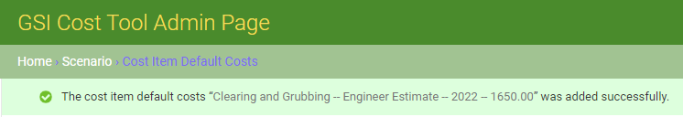

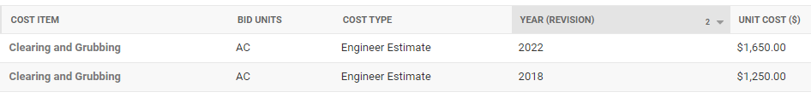

The new value will also be displayed to users in the GSI Cost Tool – in the list of default Unit Costs.

